Universal Basic
Computer Skills
Self-Paced Course

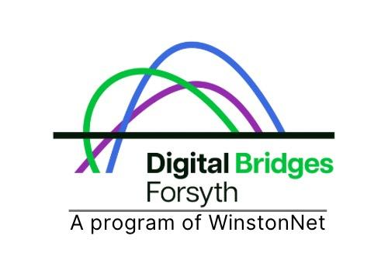
Version 1.0
Published May 2025

Welcome!
This self-paced course is for anyone who wants to feel more confident using a computer. You can go through it on your own time and speed. We encourage you to take at least 30 minutes on each module to absorb the information, but you don't need to complete the course all at once.

Do whatever works best for you.

Course Learning Goals
In this course, you'll learn how to:
- Use a computer, keyboard, and mouse
- Send email and search online
- Communicate clearly for work
- Stay safe while using digital tools

Tips for Learning
- Take breaks when you need to
- Don’t worry if you don’t understand something the first time
- Celebrate your progress—every step counts

Module 1: Basic Computer Skills

Objectives
In this module, you will:
- Learn the basic parts of a computer
- Learn how to use a keyboard and mouse
- Navigate the desktop and programs
- Learn about common software applications

Vocabulary
- application
- desktop
- file
- folder
- hardware
- software
- taskbar

What is a computer?
A computer is a tool that helps you write, search, watch videos, talk to people, and more. Computers can be desktops, laptops, or tablets and are used in grocery stores, job centers, libraries, health clinics. Computers can also be used to help in everyday life for things like online banking, telehealth, scheduling appointments, and more.
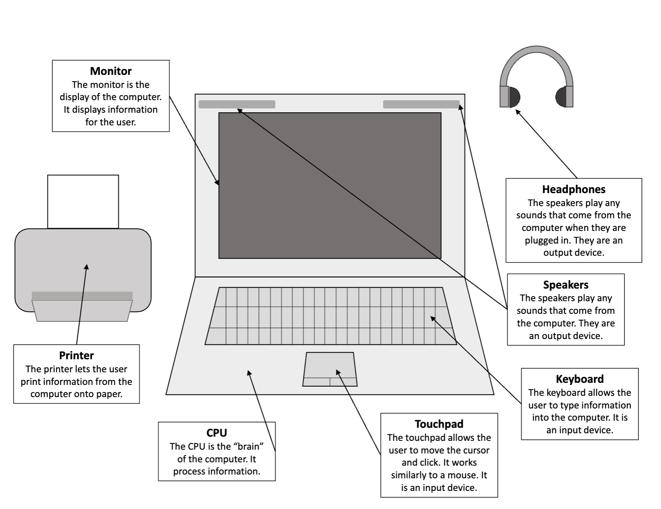

Describe the parts of the computer in your own words and then label in the diagram:
CPU __________________________________________________________________________________________________________________

Monitor ____________________________________________________________________________________________________________

Keyboard
____________________________________________________________________________________________________________

Mouse/Trackpad
__________________________________________________________________________________________________________________

Headphones __________________________________________________________________________________________________________________

Speaker
__________________________________________________________________________________________________________________

Printer __________________________________________________________________________________________________________________

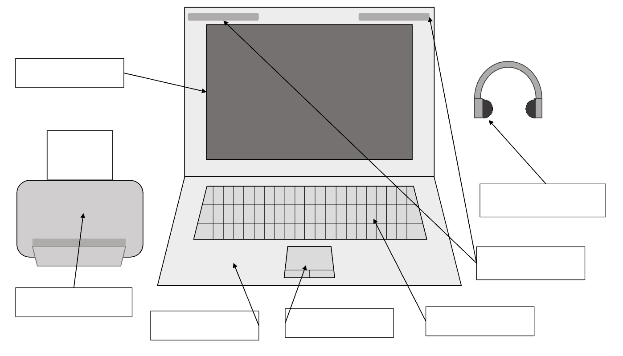

Keyboard and Mouse Basics
The keyboard lets you type words and numbers. The mouse/trackpad helps you click, move things, and open programs.

Put it into Practice
- I typed my name using the keyboard.
- I used the mouse to open a folder or program.

Using the Computer
Most computers use an operating system like Windows, MacOS, and ChromeOS. You can click the Start menu or use the search bar to find programs like:
- Calculator
- Word Processor (like Google Docs or Microsoft Word)
- Internet browser (like Safari, Google Chrome or Microsoft Edge)

Put it into Practice
- I found and opened a program from the Start menu.

Common Software
Software is what helps you do things on your computer. Common software includes:
- Word processors (for writing documents)
- Spreadsheets (for organizing data)
- Web browsers (for using the internet)

Write down one software you’ve used before:
__________________________________________________________________________________________________________________

Activity: Software Icon Matching
Write the name of the software icon on the line.
 __________________________________

 __________________________________

 __________________________________

 __________________________________

 __________________________________

 __________________________________

 __________________________________

 __________________________________

 __________________________________

 __________________________________

 __________________________________

 __________________________________

 __________________________________

*Answers in Appendix on page 29

Wrap Up
What is one thing you learned in this module?
____________________________________________________________________________________________________________________________________________________________________________________________________________________________________

What is one thing you want to keep practicing?
____________________________________________________________________________________________________________________________________________________________________________________________________________________________________

Nice work! You’ve just explored the basics of using a computer. Computers are powerful tools—and you're learning how to use them.
Next, we’ll take a look at email and the internet so you can connect with others and find information online.

Module 2: Email and Internet

Objectives
In this module, you will:
- Set up a free email account using Gmail.
- Learn how to send and reply to emails.
- Practice attaching files to an email.
- Use a search engine to find information online.
- Explore how to stay safe while using the internet.

Vocabulary
- attachment
- browser
- inbox
- link
- scam
- search engine
- spam
- subject line

Set Up Your Gmail Account
If you don’t already have an email address, here’s how to create one:
- Go to www.gmail.com and click 'Create account'
- Fill in your name, username, and password
- Follow the prompts to enter your info and accept the terms
- Log in and explore your inbox

My Gmail address: _________________________________________________________

Password hint (optional): _________________________________________________________

Using Email
Email is a great way to communicate because it's a fast, efficient, and convenient way to send and receive messages, even across different time zones. You can use it to apply for jobs, get updates, and talk with people.

You can share information, documents, and even video with just a few clicks. It also provides a record of your communication, making it easier to refer back to later.

Parts of an email:
- To: the person you’re sending it to
- Subject: a short title for your message
- Message: what you want to say
- Attachment: a file or photo you send with your message

Put it into Practice
- I opened my email account.
- I wrote a message and sent it.
- I added a subject line.
- I attached a file or picture.

Spam vs Safe Messages
If you’ve ever found your inbox filled with unwanted email ads, you’ve likely encountered spam—also known as junk mail. These messages not only create clutter, making it harder to spot important emails, but they can also carry serious threats like phishing scams or malware. Thankfully, most email providers offer built-in tools to help filter out spam and keep your inbox safer and more organized.

Look out for things like messages asking for money or passwords, lots of spelling mistakes, and links that look strange or suspicious.

Steps to Stay Safe
- Avoid clicking links.
- Close suspicious websites.
- Report phishing if available.

What is the Internet?
The internet is a big network that connects computers and devices all over the world so they can share information.

You can think of it like a giant "information highway" where people can send and receive things like emails, websites, and video calls.

When your computer is connected to the internet—also called being "online"—you can look up information, talk to people anywhere in the world, and do many other things.

Searching the Internet
The internet has many different websites filled with information, like news, videos, pictures, or places to shop and learn. This is called the World Wide Web, or just "the Web."

To look at these websites, you use something called a web browser—like Chrome, Safari, or Firefox. A web browser is the tool that lets you visit websites and see what’s on them, like reading a digital newspaper or watching a video.

To help you find websites on the internet, you use a search engine—like Google or Bing. A search engine is like a helpful librarian. You type in a word or question, and it looks through the internet to find websites that match.

Using a browser and search engine together makes it easy to explore and learn about anything you’re interested in.

Put it into Practice
- I opened a web browser (like Google Chrome, Mozilla Firefox, etc).
- I typed something into a search bar.
- I looked at a search result.

Wrap Up
What is one way you can use email in your life?
___________________________________________________________________________________________________________________________________________________________________________

What’s one thing you want to remember about searching online?
___________________________________________________________________________________________________________________________________________________________________________

You did it—email and internet skills are now part of your toolbox.
In the next section, we’ll talk about how these digital skills help with jobs, communication, and reaching your goals.

Module 3: Workforce Skills

Objectives
In this module, you will:
- Practice communication strategies for the workplace.
- Learn time management and goal-setting tools.
- Understand resume purpose and structure, and start compiling personal experience and skills for a future draft.
- Explore job search websites and find job postings.

Vocabulary
- application
- communication
- goal
- interview
- job posting
- resume
- time management
- workplace

Communication at Work
Clear communication can help you apply for jobs, ask questions, and stay connected.

Communicating at Work
- Business writing: emails, memos, and reports
  - These should be clear, polite, and easy to read.
- Instant messaging and text messages: quick updates or questions
  - These are usually more casual and remain respectful and professional.
  - Keep messages short and to the point and avoid using slang or emojis unless you know it’s okay in your workplace.
- Interpersonal communication: in-person conversations, phone calls, or video meetings
  - In American work culture, it is considered respectful and professional when you are polite, speak clearly, listen carefully, and make eye contact.

Tips
- Know what you need to say
- Think about who will hear or read it
- Get to the point right away
- Use simple, clear language
- In American work culture, it is common to use polite words like “please” and “thank you”

Put it into Practice
Write a short professional email to request an interview or follow up:
________________________________________________________________________________________________________________________________________________________________________________________________________________________________________________________________________________________________________________________________________________________________________________________________________________________________________________________________________
_________________________________________________________
_________________________________________________________
_________________________________________________________

Time Management and Goals
Time management means planning ahead so you can finish tasks and feel less stressed.
Setting goals helps you know what you want to work toward.

Put it into Practice
What is one thing you want to get done this week?
____________________________________________________________________________________________________________________________________________________________________________________________________________________________________

Write a short-term goal for your learning or job search:
____________________________________________________________________________________________________________________________________________________________________________________________________________________________________

My Weekly Plan
- I filled out a planner or wrote down my tasks.
- I set a goal that feels realistic for me.

Resume Basics
A resume is a short document that tells an employer about your work experience, skills, and education. It explains why you would be a good fit for the job you’re applying for.

Think of a resume like a personal advertisement. It should be clear, simple, and easy to read. You want the person reading it to quickly understand what you can do and why they should interview you.

Use the template below and fill out your information to get your resume started.
- My name: _______________________________________________
- Phone and email: __________________________________________
- Things I’ve done that count as work: _______________________________________________________________________________________________________________________________________________________________
- What am I good at?
_______________________________________________________________________________________________________________________________________________________________
- Education or training I’ve had:
_______________________________________________________________________________________________________________________________________________________________

Job Searching
You can use websites like Career Builder (careerbuilder.com), Glassdoor (glassdoor.com) , Indeed (indeed.com), LinkedIn (linkedin.com), NCWorks (ncworks.gov), USA Jobs (usajobs.gov), or Zip Recruiter (ziprecruiter.com), or to find job postings.
A job posting will usually tell you:
- Job title
- Schedule and location
- Skills or experience needed

Put it into Practice
Find a job posting and answer the following
Job Title: _________________________________________________________

Where you found it: _________________________________________________________

One thing the job requires: _________________________________________________________

Wrap Up
What is one new thing you learned about finding a job?
____________________________________________________________________________________________________________________________________________________________________________________________________________________________________

What is one skill you want to keep building?
____________________________________________________________________________________________________________________________________________________________________________________________________________________________________
You’ve been working hard to connect your digital skills to real-life goals. Our final part will help you stay safe and confident as you use technology—because your privacy and power matter.

Module 4: Security

Objectives
In this part, you will:
- Learn about staying safe online.
- Practice recognizing scams and phishing attempts.
- Explore AI opportunities and risks.
- Build confidence in making digital choices that protect your information.

Vocabulary
- AI (Artificial Intelligence)
- algorithm
- cybersecurity
- permissions
- personal information
- privacy
- scam
- spam

Cybersecurity and Staying Safe Online
Cybersecurity means staying safe and protecting your personal information when you use the internet. It is important for both people and businesses.
- It protects your private information. Cybersecurity helps keep things like your name, address, Social Security number, and bank details from being stolen or misused.
- It helps businesses keep running. If a business is attacked online, it can lose money, damage its reputation, or even be forced to close for a while.
- It keeps our communities safe. Sometimes, online attacks can target important systems like hospitals, power plants, or water supplies. Good cybersecurity helps keep these services running safely.

Identify Red Flags
- Seem to be from legitimate companies like banks, internet service providers, credit card companies, etc.
- Are unsolicited (you didn't ask for it; they just sent it to you)
- Ask for things like usernames, passwords, account numbers, etc.
- Offer something seemingly valuable, like a prize or discount
- Often includes typos in the email
- Have strange email addresses or typos in the email address
- Have wild titles

Online Safety Checklist
- I think before I click.
- I delete or ignore messages that look like scams.
- I protect my personal information.
- I say no or ask for help if I’m unsure.
- I only share things online that I’m comfortable being public.
- I use passwords that are strong and private.
- I know it’s okay to pause before responding.

Bonus tip: What is a VPN?
A VPN (Virtual Private Network) is a tool that helps protect your personal information online. It’s especially useful when you use public Wi-Fi (like at a coffee shop or the library). You don’t need to use one every day, but it’s a good tool to know about.

Put it into Practice
- I looked at an example of a scam or phishing message.
- I talked to someone if I wasn’t sure about a message.
- I closed a website or message that didn’t feel safe.

Privacy Overview
Online privacy is about protecting your personal information while using the internet. It's about having control over what information is shared, how it's used, and who has access to it.

Apps and websites often ask to use your location, microphone, or other data. You can choose what to allow.

Put it into Practice
Name one app or website you use often.
___________________________________________________________________________________________________________________________________________________________________________

What information does it ask for?
___________________________________________________________________________________________________________________________________________________________________________

What would you want to keep private?
___________________________________________________________________________________________________________________________________________________________________________

What is Artificial Intelligence?
Artificial Intelligence, often called AI, is just a tool. Most AI refers to computerized systems that train on data to learn, think, and make decisions like humans, but much faster and on a larger scale.

Most types of AI can be broken down into 3 parts. A dataset, an algorithm, and an output or prediction.
- A dataset is a collection of data that you put together. Data can include anything! We typically think of data as numbers, but it could also be a collection of text, video, or images.
- An algorithm is just a series of steps or instructions that you repeat.
- An output or prediction is the result of what an algorithm does based on information. An output can include text, images, and recommendations.

Opportunities and Risks
While AI can be helpful and create new opportunities, it can also be harmful and create or increase existing risks.
- Opportunities:
  - Productivity
  - Creativity
- Risks:
  - Bias
  - Misinformation
  - Privacy

Put it into Practice
- I watched the algorithm video to understand more about how AI works.
- I reflected on the software and apps I use that have integrated AI and how there may be risks involved with using them.

Wrap Up
What’s one safety tip you want to remember?
____________________________________________________________________________________________________________________________________________________________________________________________________________________________________

What makes you feel more confident online?
____________________________________________________________________________________________________________________________________________________________________________________________________________________________________

You’ve made it through all four parts—amazing work!
Let’s take a moment to reflect on what you’ve learned, set your own digital goals, and celebrate your growth.

Wrap Up

Congratulations!
You’ve completed all four modules of the self-paced Universal Basic Computer Skills course. You’ve practiced using a computer, explored email and the internet, connected your learning to real-world jobs, and built skills to protect your safety online.

This is just the beginning of your digital journey—well done!

Final Reflection
What is something you’re proud of learning?
___________________________________________________________________________________________________________________________________________________________________________

What is one skill you want to keep practicing?
___________________________________________________________________________________________________________________________________________________________________________

How will digital skills help you in your life?
___________________________________________________________________________________________________________________________________________________________________________

My Digital Goals
What do you want to learn next?
- How to use video calls (Zoom, Google Meet)
- How to use online banking
- How to use telehealth
- How to create and save documents
- A deeper dive into AI
- Something else: _______________________________________________

Appendix

Activity: Software Icon Matching Answer Key

Safari

Microsoft Outlook

Google Slides

Adobe Suite

Microsoft Excel

Google Chrome

Gmail

Zoom

Google Sheets

Microsoft PowerPoint

Calculator

Google Docs

Microsoft Word

